9. ReactJS-HOL

Components – IndianPlayer.js

import React from 'react';

const IndianPlayers = () => {

const teamPlayers = [

'Rohit Sharma',

'Hardik Pandya',

'Jasprit Bumrah',

'Virat Kohli',

'Suryakumar Yadav',

'Ravindra Jadeja',

'MS Dhoni',

'Rishabh Pant',

'Kuldeep Yadav',

'Shubman Gill',

'Mohammed Shami',

];

const oddTeamPlayers = teamPlayers.filter((_, index) => (index + 1) % 2 !== 0);

const evenTeamPlayers = teamPlayers.filter((_, index) => (index + 1) % 2 === 0);

const t20Players = ['Hardik Pandya', 'Suryakumar Yadav', 'Rishabh Pant'];

const ranjiTrophyPlayers = ['Jaydev Unadkat', 'Sarfaraz Khan', 'Arpit Vasavada'];

const mergedPlayers = [...t20Players, ...ranjiTrophyPlayers];

return (

<div>

<h2>Indian Players</h2>

<h3>Odd Team Players</h3>

<ul>

{oddTeamPlayers.map((player, index) => (

<li key={index}>{player}</li>

))}

</ul>

<h3>Even Team Players</h3>

<ul>

{evenTeamPlayers.map((player, index) => (

<li key={index}>{player}</li>

))}

</ul>

<h3>Merged T20 and Ranji Trophy Players</h3>

<ul>

{mergedPlayers.map((player, index) => (

<li key={index}>{player}</li>

))}

</ul>

</div>

);

};

export default IndianPlayers;

components-ListOfPlayers.js

import React from 'react';

const ListOfPlayers = () => {

// Declare an array with 11 players

const players = [

{ name: 'Virat Kohli', score: 85 },

{ name: 'Rohit Sharma', score: 92 },

{ name: 'Shubman Gill', score: 45 },

{ name: 'Suryakumar Yadav', score: 78 },

{ name: 'Hardik Pandya', score: 65 },

{ name: 'Ravindra Jadeja', score: 50 },

{ name: 'MS Dhoni', score: 105 },

{ name: 'Rishabh Pant', score: 30 },

{ name: 'Jasprit Bumrah', score: 15 },

{ name: 'Mohammed Shami', score: 20 },

{ name: 'Kuldeep Yadav', score: 5 },

];

const playersBelow70 = players.filter(player => player.score < 70);

return (

<div>

<h2>List of Players</h2>

<h3>All Players</h3>

<ul>

{}

{players.map((player, index) => (

<li key={index}>

{player.name} - Score: {player.score}

</li>

))}

</ul>

<h3>Players with Score Below 70</h3>

<ul>

{}

{playersBelow70.map((player, index) => (

<li key={index}>

{player.name} - Score: {player.score}

</li>

))}

</ul>

</div>

);

};

export default ListOfPlayers;

APP.js

import React from 'react';

import ListOfPlayers from './components/ListOfPlayers';

import IndianPlayers from './components/IndianPlayers';

import './App.css';

function App() {

const flag = true;

return (

<div className="App">

<header className="App-header">

<h1>Cricket App</h1>

</header>

{flag ? <ListOfPlayers /> : <IndianPlayers />}

</div>

);

}

export default App;

Output

10 – REACTJS-HOL

Components-OfficeSpace.js

import React from 'react';

const OfficeSpace = () => {

const office = {

name: 'DBS',

rent: 50000,

address: 'Chennai'

};

return (

<div>

<h1>Office Space , at Affordable Range</h1>

<img src="https://images.unsplash.com/photo-1541746972966-aa612f81498e?q=80&w=1858&auto=format&fit=crop&ixlib=rb-4.0.3&ixid=M3wxMjA3fDB8MHxwaG90by1wYWdlfHx8fGVufDB8fHx8fA%3D%3D" alt="Office Space" style={{ maxWidth: '400px' }} />

<h3>Name: {office.name}</h3>

<p>Rent: <span style={{ color: office.rent < 60000 ? 'red' : 'green' }}>Rs. {office.rent}</span></p>

<p>Address: {office.address}</p>

</div>

);

};

export default OfficeSpace;

App.js

import React from 'react';

import OfficeSpace from './components/OfficeSpace';

import './App.css';

function App() {

return (

<div className="App">

<OfficeSpace />

</div>

);

}

export default App;

OUTPUT

11-REACTJS-HOL

Components -CurrencyConverter.js

import React, { useState } from 'react';

const CurrencyConvertor = () => {

const [rupees, setRupees] = useState(0);

const [euros, setEuros] = useState(0);

const handleChange = (e) => {

setRupees(e.target.value);

};

const handleSubmit = (e) => {

e.preventDefault();

const conversionRate = 88;

const result = rupees / conversionRate;

setEuros(result.toFixed(2));

};

return (

<div>

<h2>Currency Convertor</h2>

<form onSubmit={handleSubmit}>

<label>

Indian Rupees (INR):

<input type="number" value={rupees} onChange={handleChange} />

</label>

<br />

<button type="submit">Convert</button>

</form>

<h3>Converted Value: {euros} Euro</h3>

</div>

);

};

export default CurrencyConvertor;

components-EventExample.js

import React, { useState } from 'react';

const EventExamples = () => {

const [count, setCount] = useState(0);

const [message, setMessage] = useState('');

const incrementValue = () => {

setCount(prevCount => prevCount + 1);

};

const sayHello = () => {

alert("Hello followed by a static message.");

};

const handleIncrement = () => {

incrementValue();

sayHello();

};

const decrementValue = () => {

setCount(prevCount => prevCount - 1);

};

const sayWelcome = (word) => {

alert(word);

};

const handlePress = () => {

setMessage('I was clicked');

};

return (

<div>

<h2>Event Handling Examples</h2>

<div>

<p>Counter: {count}</p>

<button onClick={handleIncrement}>Increment</button>

<button onClick={decrementValue}>Decrement</button>

</div>

<hr />

<div>

<button onClick={() => sayWelcome('Welcome')}>Say Welcome</button>

</div>

<hr />

<div>

<button onClick={handlePress}>Synthetic Event OnPress</button>

<p>{message}</p>

</div>

</div>

);

};

export default EventExamples;

APP.js

import React from 'react';

import EventExamples from './components/EventExamples';

import CurrencyConvertor from './components/CurrencyConvertor';

import './App.css';

function App() {

return (

<div className="App">

<header className="App-header">

<h1>Event Examples App</h1>

</header>

<EventExamples />

<hr />

<CurrencyConvertor />

</div>

);

}

export default App;

OUTPUT

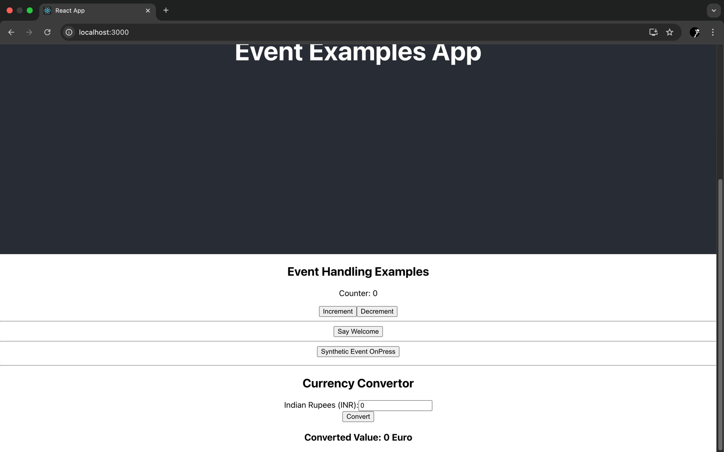

12.REACTJS-HOL

APP.js

import React, { useState } from 'react';

import './App.css';

function App() {

const [isLoggedIn, setIsLoggedIn] = useState(false);

const handleLogin = () => {

setIsLoggedIn(true);

};

const handleLogout = () => {

setIsLoggedIn(false);

};

return (

<div className="App">

<header className="App-header">

{isLoggedIn ? (

<>

<h1>Welcome back</h1>

<button onClick={handleLogout}>Logout</button>

</>

) : (

<>

<h1>Please sign up.</h1>

<button onClick={handleLogin}>Login</button>

</>

)}

</header>

</div>

);

}

export default App;

OUTPUT

ddd

13.REACTJS-HOL

Components-CourseDetails.js

import React from 'react';

const CourseDetails = () => {

return (

<div className="column">

<h2>Course Details</h2>

<h3>Angular</h3>

<p>4/5/2021</p>

<h3>React</h3>

<p>6/3/20201</p>

</div>

);

};

export default CourseDetails;

components-BookDetails.js

import React from 'react';

const BookDetails = () => {

return (

<div className="column">

<h2>Book Details</h2>

<h3>Master React</h3>

<p>670</p>

<h3>Deep Dive Into Angular 11</h3>

<p>800</p>

<h3>Mongo Essentials</h3>

<p>450</p>

</div>

);

};

export default BookDetails;

components-Blogdetails.js

import React from 'react';

const BlogDetails = () => {

return (

<div className="column">

<h2>Blog Details</h2>

<h3>React Learning</h3>

<p>Stephen Biz</p>

<p>Welcome to learning React!</p>

<h3>Installation</h3>

<p>Schewzdenier</p>

<p>You can install React from npm.</p>

</div>

);

};

export default BlogDetails;

App.js

import React, { useState } from 'react';

import CourseDetails from './components/CourseDetails';

import BookDetails from './components/BookDetails';

import BlogDetails from './components/BlogDetails';

import './App.css';

function App() {

const [showCourses] = useState(true);

const [showBooks] = useState(true);

const renderBlogs = (shouldRender) => {

if (shouldRender) {

return <BlogDetails />;

}

return null;

};

return (

<div className="App">

<div className="container">

{showCourses && <CourseDetails />}

{showBooks ? <BookDetails /> : null}

{renderBlogs(true)}

</div>

</div>

);

}

export default App;

App.css

.App {

text-align: center;

}

.container {

display: flex;

justify-content: center;

padding: 20px;

}

.column {

flex: 1;

padding: 10px;

margin: 0 10px;

border-left: 2px solid green;

}

.column:first-child {

border-left: none;

}

OUTPUT

